Free Second-Hand Clothing Distribution System
Process Modeling and Data Modeling /
System Proposal / Analysis Phase
(Homework No.3)

Project team: Team 02
Instructor: Dr. Araz Yusubov

Submitted in partial fulfillment of the requirements of the INFT 2303: Systems Analysis and Design course project

GitHub repository | https://github.com/ADA-SITE-INFT2303-2023-Spring/<name of the repository>
Version date | Version information
<Date> | Initial draft
<Date> | <Version description>

Other documents in the package
File name | Brief description of the document
<File name> | <Description of the document>
<File name> | <Description of the document>

Team member | Contribution to this homework (NOT the project) | Estimated %
<Student Name 1> | <Description of the work contributed> | <X>%
<Student Name 2>
<Student Name 3>
<Student Name 4>

Table of Contents
<Automatically generate here using Microsoft® Word menu References→Table of Contents>

Introduction
This is part of the System Proposal for a hypothetical Free Second-Hand Clothing Distribution System submitted for partial fulfillment of the requirements of the Systems Analysis and Design course in the School of Information Technologies and Engineering at ADA University, Baku, Azerbaijan.

A project called the Free Second-Hand Clothing Distribution System seeks to develop a platform for the effective and long-lasting distribution of used clothes to people in demand. Through a variety of modeling tools, such as process modeling, data modeling, CRUD matrix, and UML activity diagrams, this article offers an in-depth understanding of the system. This document's main objective is to give readers a thorough knowledge of the functionality, data flow, and workflow of the system. During the system's development and deployment, it will act as a guide for programmers, clients, and project managers. The many modeling approaches employed will be described in depth in the sections that follow, along with descriptions of each part.

<DELETE each and every instructional paragraph between (and including) < and > everywhere in the document and REPLACE ALL of them with your text. Keep the main numbered sections, but feel free to add sub-sections if needed.

All consequent homework assignments will be based on this document, so give it enough thought.>

<Briefly describe the content of the document and work done to prepare it. This document must be submitted in original Microsoft© Word format.>

<While doing analysis and getting better understanding of the system you may need to make changes in the HOMEWORK No.1B/2 document, such as additions/modifications to product functions or use cases. In this case Homework No.1B/2 document should be submitted, too. Edits in these documents should be visible by turning the TRACK CHANGES option on through Review→Track Changes menu and version information on the title page should be updated.

Bonus 1: Get extra 15% points for revising and SUBSTANTIALLY improving the Homework 1/2 document.

All Microsoft© Word documents should be submitted as separate files. Any additional files of other types e.g. diagram and charts will usually be inserted to this document as embedded images, but the source files should also be submitted in a SINGLE .zip archive file.>
< Submit your assignment through the course website:
- Use your GitHub repository to keep all your project files and make sure all team members update it regularly. The teams are expected to submit their homework through Blackboard, at the same time their work must be traceable through the GitHub Classroom.
- Submit to the grader the following files before the deadline:
  - Process Modeling and Data Modeling (this document) as Microsoft© Word documents.
  - For Bonus 1, System Request and Feasibility Study (Homework No.1B) or/and Requirements Determination and Use Case Analysis (Homework No.2) as a Microsoft© Word document with tracked changes.
  - Any additional files of other types e.g. diagram and charts will usually be inserted to this document as embedded images or tables. At the same time, the source files e.g. Excel .xlsx files or Diagrams.Net .drawio files should also be submitted inside a single .ZIP archive file.
- Do not forget to inform your team mates, to avoid multiple submissions.
- You will be graded based on your contribution to the team submission, which is to be evaluated for its clarity, technical soundness, thoroughness and coverage, relevance and utilization of resources.
>

<This section is accounting for about 6% of your assignment grade.>

Definitions
<Every time you come across a project-specific term (which can be interpreted differently e.g. “terminal”), add a short description of it to the table below. Insert here any technical word for which the meaning may not be known. DO NOT assume that the readers have specialized knowledge. Use a table format for these.>

Term | Definition
<Term> | <Detailed term definition>

<This section is accounting for about 4% of your assignment grade.>

Process Modeling
<This and next section contains all the logical process and data models. Remember this is NOT design. Focus on logical modeling, and do not be distracted by technical implementation details, software packages, etc. >

<Draw the context-level diagram for the system. In this section you will refer to use cases you identified in Homework 2 to create data flow diagram fragments that eventually will be combined into data flow diagrams.

Here and in the following sub-sections list all processes, data flows, data stores and external entities with a short textual description. Indicate related use case number and name in the description.

Discuss the process of validation of data flow diagrams and explain any possible “anomalies”.

<This section is accounting for about 10% of your assignment grade, and the diagrams for about additional 10 %.>
In this context diagram, we have 4 external entities, donee, donor, system admins, and customer support. Admin is mainly responsible for user details, and clothing service details, customer support is responsible for sorting, organizing, and distribution details. Donee and donors are the main users of the Free Second-Hand Clothing Distributed System. Donee sends requests for receiving clothes by introducing personal information and ongoing data flows are "confirmation about request" and "Clothing details" for Donee. Donor donates second-hand clothing by introducing personal information and clothing details, its ongoing data flow is "Confirmation of donation".

Bonus 2: Get extra 10% points for complementing all process descriptions with UML activity diagrams. For the context-level diagram it must be in a form of a swim lane diagram.>

Level 0 diagram
<Draw Level 0 data flow diagram for the system.>

<This section is accounting for about 10% of your assignment grade, and the diagrams for about additional 20 %.>
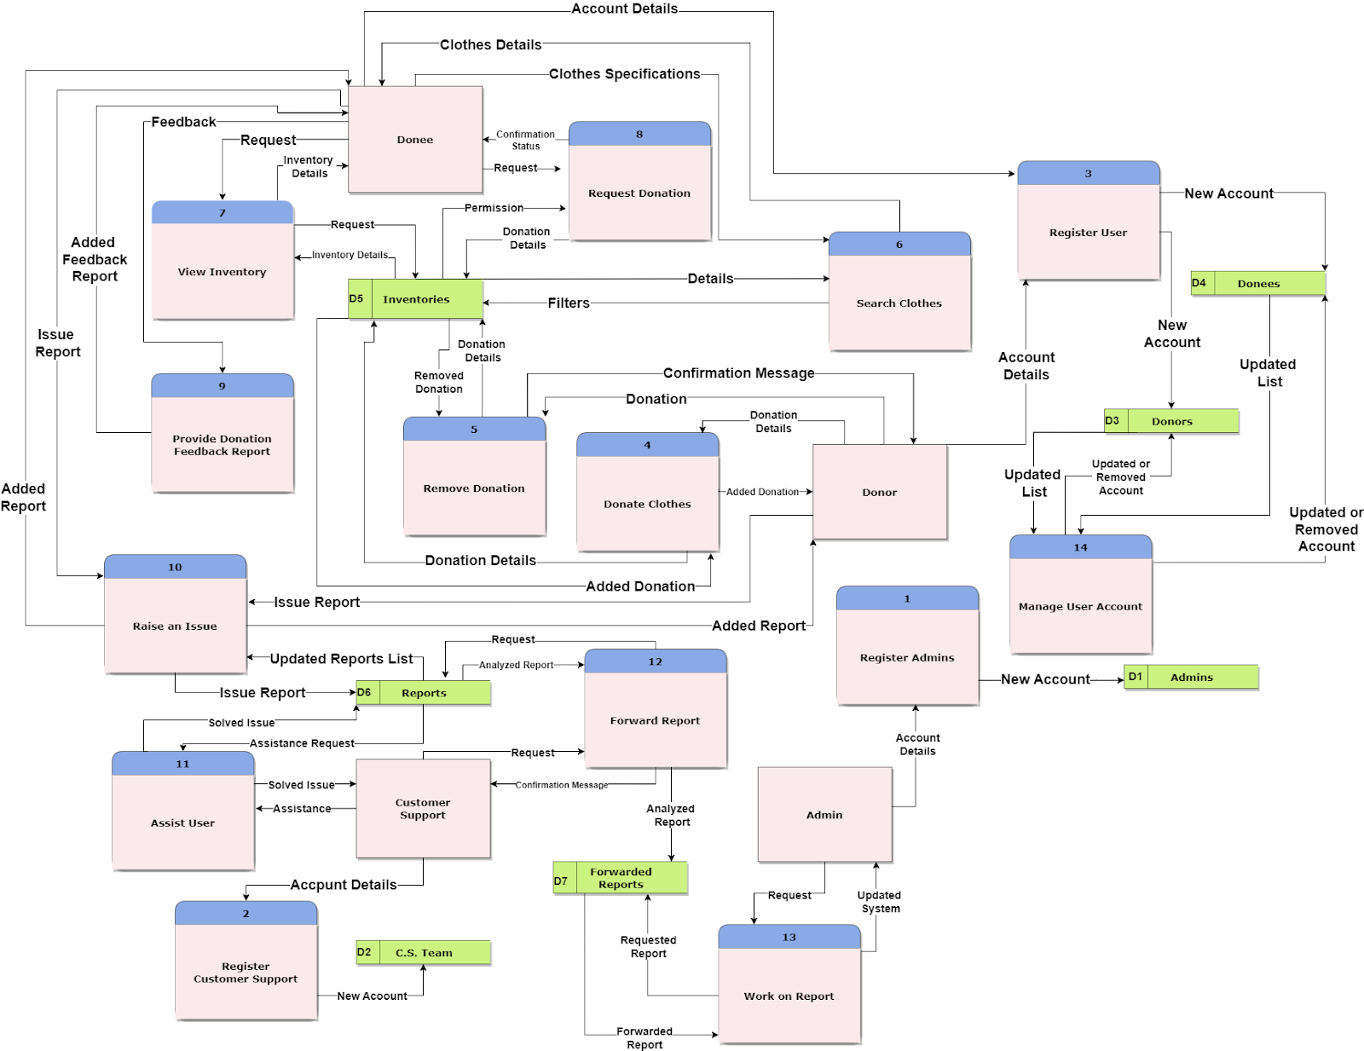

External Entities:
- Admin
- Customer Support
- Donor
- Donee

Processes:
- Register Admin - The process takes the account details to register the admin account. The account information is saved on the data store as a new account.
- Register Customer Support - The process takes the account details to register the “Customer Support” account. The account information is saved on the data store as a new account.
- Register User - The process takes the account details to register both donor and donee accounts. The information is saved on the data store as a new account.
- Donate Clothes - Donor entity sends the donation details to the process for saving it as a new donation on the “inventories” data store. Then the data store sends the updated list of the new “inventories” list.
- Remove Donation - Donor entity sends donation details to the process for sending a request to the data store “inventories” for deleting it.
- Search Clothes - Donee sends specified donation details to the process which sends a request to the “inventories'' data store for filtering and finding the related clothes on the data store. Then the Data store sends related donation details which are saved on the system.
- View Inventory - Donee sends the request to the process which also sends a request to the “inventories” data store for getting the inventory details.
- Request Donation - Donee sends the donation details to the process for sending a request to the data store for getting permission on requested donation.
- Provide Donation Feedback - Donee sends the feedback report about the donation to the process. After that, the process saves the report on the “Reports” data store and sends the confirmation message to the Donee entity.
- Raise an Issue - Both donee and donor sends the Issue Report to the process which saves them in the “Reports” data store. Then the confirmation message is sent to the users.
- Assist User - Customer support sends an assistance request to the process. Process takes the Reports (which donor and donee reported for feedback or issue) from the data store and realizes the assistance process. Then the solved issue details are sent to the customer support.
- Forward Feedback Report - Customer support analyzes the reports on the data store “Reports” and sends the analyzed reports to the process. Then the process saves the reports on the “Forwarded Reports” data store.
- Work on Report - Admin sends a request to the process which takes the forwarded reports from the data store “forwarded reports”. Next, the process works on the report, improves or solves the related issue and sends the updated system details to the admin entity.
- Manage User Account - Admin sends details about the process should be taken on the account to the process. Process refers to the data stores (donee, donor) to get the required account and make operations on the data store. Then the data store sends the updated list of the donor/donee to the admin entity.

Data Stores
- Admins
- Donors
- Donees
- C.S Team (Customer Support)
- Inventories
- Reports
- Forwarded Reports

Evaluating DFDs
Process
- Every process has a unique, action-oriented verb phrase names, and a number
- Every process has at least one input and output data flow.
- Output data flows have different names than input data flows
Data Flow
- Every data flow has a name that is a noun, and a description.
- Every data flow connects to at least one process.
Data Store
- Every data store has a unique name that is a noun
- Every data store has at least one input data flow.
- Every data store has at least one output data flow (except “Forwarded report”, “Admins”, “C.S Team”)
External Entity
- Every external entity has a unique name that is a noun
- Every external entity has at least one input or output data flow.

Level 1 diagrams
<Bonus 3: To get extra 15% points draw also all Level 1 data flow diagrams. >

Data Modeling
<This section specifies the logical requirements for any information that is to be processed by system. Draw the UML entity relationship diagrams that will be useful here to show complex data relationships.

In this section list all entities with a brief description including all attributes explained. Indicate initial entities and those added later in the process of normalization e.g. intersection entities. Discuss the relationships, including their modality and cardinality.>

Admin: This entity stands in for the system's manager or administrator, who has complete authority over and access to all system functions. An Admin may manage and supervise numerous reports since the admin entity has a one-to-many relationship with the Report entity.
Attributes:
-admin id
-admin name
-admin email
-admin password
-admin phone number
Donor: This Entity stands for people or businesses that provide the system with used clothing donations. The relationship between the Donor-> Clothing, and Report entities is one-to-many. Because of this relation, a Donor may provide many pieces of clothing.
Attributes:
-donor id
-donor name
-donor email
-donor phone number
-donor password
-donor address
Customer Support: This entity stands for the assistance provided by staff that helps users with any questions, problems, or issues they may have with the system. One customer support service representative may manage numerous Reports since the Customer Support entity has a one-to-many relationship with the Report entity.
Attributes:
-customer support id
-customer support name
-customer support email
-customer support password
-customer support phone
Donee: This entity stands for people or groups who get used clothes via the system. A Donee can get numerous pieces of clothes from the Clothing and can have numerous reports since there is a one-to-many relationship between the Donee-> the Clothing and Report entities.
Attributes:
-donee id
-donee name
-donee email
-donee phone
-donee password
-donee address
Clothing: This entity illustrates the donated used clothing items. The Donee entity and the Clothing entity have a many-to-many relationship, which allows for both the Donee to get numerous clothing items and for several Donees to receive the same clothes. But between the Donor and Clothing entities, we have one-to-many relationships since one Donor can give several clothing items.
Attributes:
-clothing id
-clothing category
-clothing gender
-clothing size
-clothing color
-clothing condition
Inventory: This entity stands for every bit of the system's available supply of donated clothes. Multiple Donees may get clothes from the inventory since there is a one-to-many relationship between the Inventory and the Donee entity.
Attributes:
-donated clothing id
-donated clothing category
-donated clothing gender
-donated clothing size
-inventory location
-donated clothing color
-donated clothing condition
Report: This entity reflects the comments made by Donors and Donees regarding the functionality and user experience of the system. A single Donor and Donee may provide several reports since the Donor and Donee and the Report entity have a one-to-many connection.
Attributes:
-report id
-report content
-report type
-report status

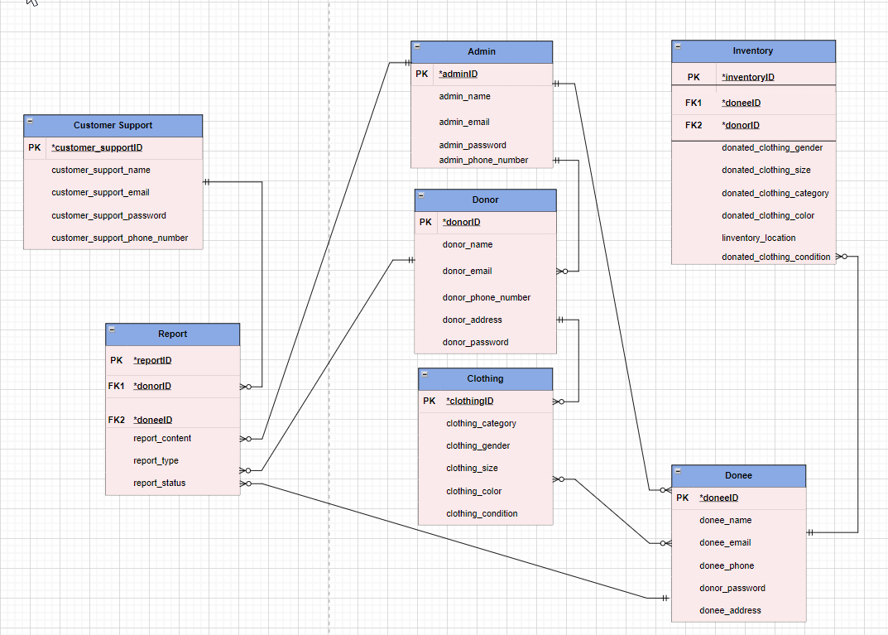

<This section is accounting for about 10% of your assignment grade, and the diagrams for about additional 15 %.>

CRUD matrix
<To balance process and data models draw your CRUD matrix in this sub-section. Use the processes from your data flow diagrams on the highest level of detail.>

<This section is accounting for about 10% of your assignment grade.>
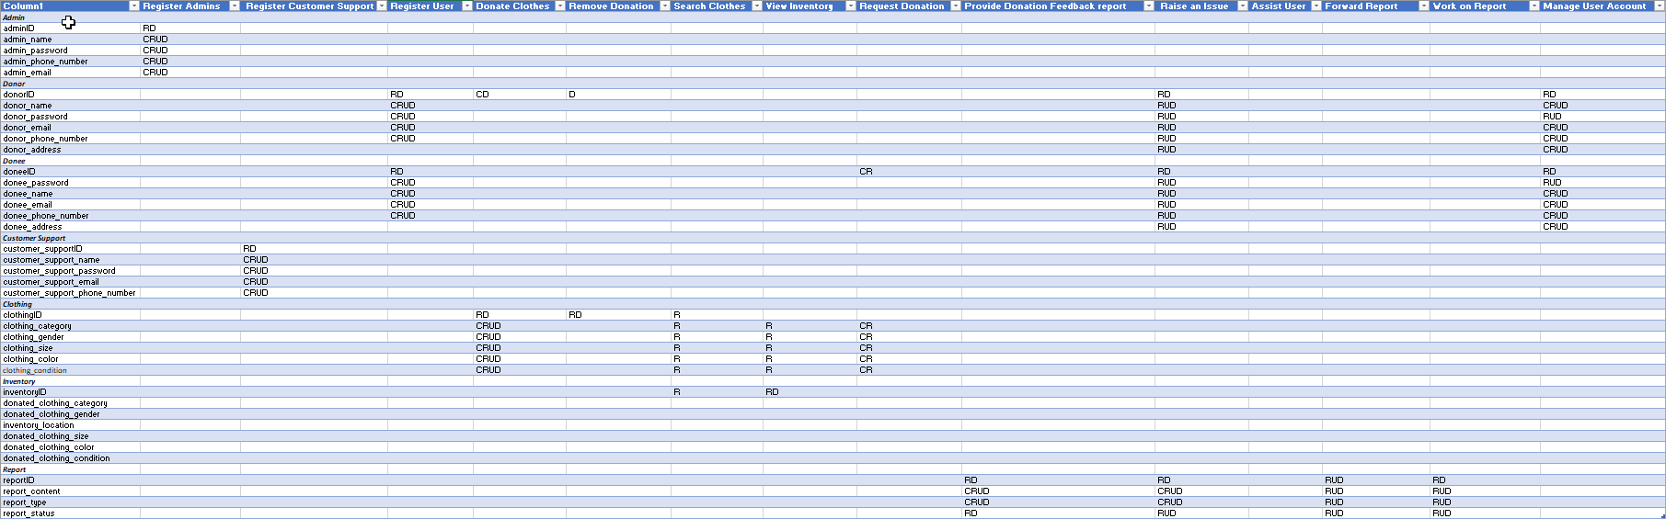

References
<Insert here any document referred to in the document. An example might be articles or Web sites that you consulted during the literature search. This is not just a list of used materials, so do not forget to clearly MARK the exact points(s) of reference in the main text.

This can be done by adding endnotes at the exact points of reference in the main text.>

<This section is accounting for about 5% of your assignment grade.>

This template uses some materials by Rochester Institute of Technology Software Engineering Department.

